**MyHealth*e*Vet Baseline Usability Testing**

**Veterans Health Administration**

**Human Factors Engineering**

02/20/2015

Table of Contents

Executive Summary 4

Introduction 4

Results 5

Analysis and Comments 7

Introduction 8

Study Details 8

Application Description 9

Method Overview 9

Study Design 9

Test Configuration 9

Task Focus Areas 10

Justification for Testing 11

Test Measures 11

Participants 12

Profile 12

Key Issues and Recommendations 12

General Issues 14

High Impact Issues 14

Moderate Impact Issues 16

Low Impact Issues 17

Login Issues 18

High Impact Issues 19

Low Impact Issues: 20

Not Applicable Observations (Test Limitations) 20

Rx Refill Issues 21

High Impact Issues 22

Moderate Impact Issue 25

Low Impact Issues 26

Secure Messaging Issues 27

High Impact Issue 28

Moderate Impact Issues 29

Low Impact Issues 29

Appointments Issues 30

High Impact Issues 32

Moderate Impact Issues 33

Low impact issues 34

Not Applicable Observations 34

Blue Button Issues 35

Moderate Impact Issues 36

Low Impact Issues 38

Veterans Health Library Issues 38

Moderate Impact Issues 40

Low Impact Issue 40

Not Applicable Observations 40

User Performance Measures 41

Satisfaction 42

Perceived Utility 43

Limitations 47

General Study Design Limitations 47

Login Test Data Limitations 47

Rx Refill Test Data Limitations 47

Appointments Test Data Limitations 48

Secure Messaging Test Data Limitations 48

Conclusion 48

Appendix A: Participant Demographics and Background Information 50

Appendix B: Detailed Performance Data 52

Appendix C: Study Scripts 53

Opening Questionnaire 53

Closing Questionnaire 60

Closing 61

Appendix D: Issue Ranking System 62

Appendix E: System Usability S 63

**System Usability Scale** 63

# Executive Summary

## Introduction

My Health*e*Vet (MHV) is a Veteran facing web portal and personal health record created in 2003 and used by thousands of Veterans daily to assist in managing their health. My Health**e**Vet allows Veterans to perform tasks such as refill prescriptions online, message securely with their providers, and download health data in order to share it with non-VA clinicians. In anticipation of a redesign of My Health**e**Vet, the Human Factors Engineering office collected baseline data for key capabilities using a summative test methodology. The data will be used in two ways: First, they will inform the development of non-functional requirements for use during redesign planning. Second, the baseline metrics will be used for comparison after the re-design to determine what level of improvement has been made to ascertain the effect of site changes on the user experience.

The study design followed traditional summative testing. Fifteen participants representing the range of target users (men and women ages 40-60, see complete demographics in Appendix A) were recruited from the greater Nashville area for test sessions at HFE’s Informatics Research and Design Center (IRDC) over the course of eight days, January 28 - February 2-6, 2015. Participants were asked to complete ten common tasks in six of the most commonly used focus areas of MHV, including:

* Logon (1 task)
* Rx Refill (2 tasks)
* Secure Messaging (2 tasks)
* Appointments (2 tasks)
* Blue Button (2 tasks)
* Veterans Health Library (1 task)

Complete task descriptions are found in Appendix C: Study Scripts.

Both qualitative and quantitative data were collected. Key measures included task success (as measured by success criteria and task time success threshold), task failure, task times, mouse clicks, satisfaction (as measured by a SUS questionnaire) and coded usability findings by participant and frequency. Metrics were combined to assess overall effectiveness, efficiency and satisfaction.

## Results

The current version of My Health*e*Vet scored poorly in effectiveness, below average in efficiency and below average in satisfaction. In regards to effectiveness, the task success rate was low at 44%, with participants failing 56% of all tasks attempted. Failure was commonly due to exceeding the task time success threshold (benchmark + 100%). Participants who did succeed, did so 30% slower than the benchmark time, which is an effective average of time. Generally, effectiveness is measured solely by those tasks completed successfully. In this study however, that number is reduced so greatly by the number of task failures due to time that these failed tasks must be considered as having lowered the effectiveness and efficiency.  As for efficiency, participants who successfully completed tasks, on average, used 6 mouse clicks to complete each task. Nine out of the 10 tasks would optimally only require 2 or 3 clicks, making this a high average overall for the successful tasks. Finally, the site received a below average SUS score of 64.7, the measure of participants’ satisfaction with the site. This score, while near the average score of 68, should also be considered in light of the participants’ pattern of replying to utility portions of the closing questionnaire. As noted in the perceived utility section, participants consistently rated the site high for meeting expectations and likeliness to use, and then countered those scores with comments doubting their ability, and the ability of other veterans, to use the site.

Of the 84 total task failures (out of 150 total tasks performed by 15 participants), 38 tasks failures were due to not meeting success criteria while 69 task failures were due to exceeding the task success time threshold (with some overlap between the two types of failure). The average total times and mouse clicks across all tasks, including those failed, demonstrate the significance of these results. For example, in the first Appointments task, which only requires 3 clicks, participants averaged 12 mouse clicks and over 3 minutes (201s).

|  |  |  |  |  |  |  |  |  |  |  |
| --- | --- | --- | --- | --- | --- | --- | --- | --- | --- | --- |
|  | Login | Rx Refill 1 | Rx Refill 2 | SM 1 | SM 2 | Appts 1 | Appts 2 | BB 1 | BB 2 | VHL |
| Average Task Time (s) | 122s | 120s | 39s | 117s | 82s | 201s | 81s | 181s | 149s | 98s |
| Average Mouse Clicks | 7 | 7 | 4 | 9 | 6 | 12 | 6 | 16 | 10 | 7 |
| Required Mouse Clicks | 3 | 2 | 2 | 3 | 3 | 3 | 1 | 8 | 1 | 3 |

Table 1: Average Task Time and Mouse Clicks across all attempts

This low overall success rate represents a wide range of success within the tasks, from 20% task success in the first Appointments task to 87% task success in the Veterans Health Library task (see Detailed Performance Data for complete metrics). However, when asked to assess the most difficult and easiest tasks, nearly half (7 of 15) participants pointed to Blue Button and Appointments as difficult, while neither were mentioned as the easiest. Nine out of 15 participants ranked Login and Prescription Refill as the easiest.

Figure 1: Participant assessments of easiest and most difficult tasks

This slight disconnect between task success and perception of difficulty was magnified at the task level as participants rated the difficulty of each task as they completed it (see Key Issues and Recommendations).

## Analysis and Comments

The results are in line with previous studies and surveys performed on MHV in the past several years[1] that indicate user difficulties including:

* Difficulty effectively and/or efficiently accessing key features using the current navigation system
* Difficulties logging in and/or obtaining a login credential
* Challenges with understanding the status of appointments (especially those cancelled by the VA)
* Challenges in managing medication refills, understanding the status of a refill and tracking refills

The number of failures due to task time can, in large part, be attributed to participant difficulty in navigating to task sections. Four of nine issues rated serious were due to navigation. In total, there were 9 serious issues, 13 moderate issues, and 29 minor issues noted through analysis and coded observations of the Morae ™ recordings (see Test Configuration). A full breakdown of all issues and recommendations can be found Key Issues and Recommendations. The serious issues were as follows:

| **Issue #** | **Frequency**  **by session** | **Finding** | **Severity Rating** | **Recommendation(s)** |
| --- | --- | --- | --- | --- |
| 1 | 67% | Difficulty determining which meds are refillable | Serious | Consider adding a secondary notice (in addition to checkboxes) that a prescription is refillable or making its eligibility clear in the status label terminology. |
| 3 | 60% | Difficulty navigating to appointments | Serious | Consider placing a widget for Appointments on the front page and including it in the main navigation for the site. |
| 4 | 53% | Difficulty navigating to secure messaging | Serious | Consider placing a widget for Secure Messaging on the front page and removing the interstitial entry page and launch button. |
| 5 | 47% | Back (browser) navigation error page | Serious | Allow use of the back browser function as a standard navigation best practice. |
| 8 | 40% | Clicks info (Learn More) box bottom of homepage looking for function | Serious | Consider removing the Learn More section from the homepage. Consider adding a link directing the user to the specified area of interest once they are in the selected Learn More subsection. |
| 11 | 33% | Difficulty navigating to prescription refill | Serious | Consider adding this main function of the site to the first level of navigation. Consider eliminating entry pages for sections and utilizing drop menu to show content. |
| 17 | 27% | Confused by prescription refill language | Serious | Consider rewording the labels indicating prescription status. (see full recommendation) |
| 25 | 20% | Difficulty finding login page | Serious | Consider moving the login option to the initial Health*e*Vet page. Consider making the register button a sub-section of the login widget. |
| 34 | 7% | Attempts to login using homepage search bar | Serious | Clearly delineate the search bar from the login area as to not confuse users looking for a text-entry zone. Consider moving the login option to them MHV splash page. Consider making the register button a sub-section of the login widget. |

Table 2: Summary of serious findings and recommendations

Considering both the frequency of occurrence and impact of use on the website, HFE recommends remediating all serious issues in the upcoming redesign. Additionally, while moderate and minor issues aren’t as critical as serious issues in terms of their impact on the website, HFE recommends that as many issues as possible are addressed to improve the end-user experience.

# Introduction

## Study Details

**Study Author(s):** William Plew, [William.plew@va.gov](mailto:William.plew@va.gov)

Abigail Noonan, anoonan@arcsourcegroup.com

**HF Point of Contact:** Nancy Wilck

**Application:** MyHealth*e*Vet Website

**Study Sponsor:** Veterans and Consumer Health Informatics Office (V/CHIO)

**Developer POC:**  Jeffery Sartori RN, MS

**Devices(s):** Testing was conducted on a laptop running Windows 7 operating system on MyHealth*e*Vet version 12.11 (the VAMC Portland ‘test’ system)

## Application Description

My Health*e*Vet (MHV) is a Veteran facing web portal and personal health record created in 2003 and used by thousands of Veterans daily to assist in managing their health. My Health*e*Vet allows Veterans to perform tasks such as refill prescriptions online, message securely with their providers, and download health data in order to share it with non-VA clinicians.

## Study Objectives

In anticipation of a redesign of My Health*e*Vet, the Human Factors Engineering office collected baseline data for key capabilities using a summative test methodology. The data will be used in two ways: First, they will inform the development of non-functional requirements for use during redesign planning. Second, the baseline metrics will be used for comparison after the re-design to determine what level of improvement has been made to ascertain the effect of site changes on the user experience.

# Method Overview

## Study Design

HFE performed baseline summative testing on the website to establish key metrics that would be used again during redesign and testing of MyHealth*e*Vet. Tasks performed by participants were developed in collaboration with the Veterans and Consumer Health Informatics Office (V/CHIO).

### Test Configuration

Sessions took place at the Informatics Research and Design Center (IRDC) in Nashville, TN. Participants accessed the MHV web Portal using production level software, with fictitious educational and demonstration accounts, on a Federal government configured Laptop running Windows 7. Every participant went through a series of tasks focusing on key areas of MHV version 12.11. The participant was tasked with navigating through MHV using Internet Explorer (v9 or v11) to accomplish the series of test tasks. Sessions (audio and screen actions) were recorded using Morae™ software (v3.3.3). Morae is usability software which allows creation of tasks for a website or application and then captures pre-defined metrics for those tasks. Morae prompted the participant prior to each task with a description of the task and provided instructions regarding the objective. Upon completing each objective, the participant clicked the Morae “End Task” button, at which point they answered displayed questions before moving onto the next portion of testing. A usability specialist, serving as the test moderator, sat next to the participant during the session to assist with any technical difficulties. A note-taker participated remotely using the Web-Ex communication tool. Participants were reimbursed $60 for their time and actual mileage, up to a $25 maximum amount.

Representative(s) of HFE and the Program Office observed some of the test sessions. Standard guidelines for observers included:

* Please do not participate in the discussion unless the moderator has invited you
* Do not interrupt the participant discussion

### Task Focus Areas

1. Logon
2. Rx Refill
3. Secure Messaging
4. Appointments
5. Blue Button
6. Veterans Health Library

Each participant was prompted via Morae and by the moderator to navigate to the MHV home page between task focus areas. The study authors chose this method of navigation to provide a more replicable baseline for future repetitions of the study on new versions of MHV.

The following agenda was used for all sessions; the timing guide was adhered to as closely as possible:

|  |  |  |  |
| --- | --- | --- | --- |
| Time | *On Hour* | *On Half Hour* | Item |
| 5 min | :00 | :30 | **Introduction**   * Greet the participant * Read introductory script * Consent to Record & Begin Morae Recording & Backup WebEx Recording * Instruct the participant to complete the Opening Questionnaire on the screen and further Morae Autopilot Tasks |
| 5 min | :05 |  | **Opening Questionnaire**   * Displayed via Morae Autopilot |
| 43 min | :10 |  | **Task Completion**   * Read pre-task briefing before participant begins tasks * Instruct the participant to read the task scenario and when ready to begin the task, to click the “Start Task” button. * Instruct the participant to click the “Finish Task” button when they think they’re done with the task. |
| *4 min* | *:10* |  | *Task 1: MHV Logon* |
| *4 min* | *:14* |  | *Task 2: Rx Refill 1* |
| *3 min* | *:18* |  | *Task 3: RX Refill 2* |
| *5 min* | *:21* |  | *Task 4: Secure Messaging 1* |
| *4 min* | *:26* |  | *Task 5: Secure Messaging 2* |
| *5 min* | *:30* |  | *Task 6: Appointments 1* |
| *4 min* | *:35* |  | *Task 7: Appointments 2* |
| *4 min* | *:39* |  | *Task 8: Blue Button 1* |
| *4 min* | *:43* |  | *Task 9: Blue Button 2* |
| *5 min* | *:47* |  | *Task 10: Veterans Health Library* |
| 5 min | :52 |  | Closing Questionnaire   * Produced by Morae Autopilot |
| 5 min | :57 |  | System Usability Scale (SUS)   * Produced by Morae Autopilot |
| 3 min | :62 |  | Closing   * Thank the participant for their time and cooperation * Ask for any final questions |

Complete study materials can be found in Appendix C: Study Scripts.

### Justification for Testing

MHV leadership recommended the above Task Focus Areas undergo usability testing, based on a review of articles, papers and reports on the MHV portal. Actual Help Desk requests by MHV users provided the best objective measure and portray the need for a usability assessment.

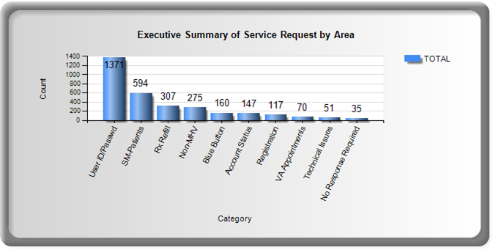

Figure 2: a study of the current MHV site

### Test Measures

During summative testing a number of metrics were captured. This report provides baseline measures as follows:

* Effectiveness - Objective measures of task success, task failures, and errors.
* Efficiency – Objective measures of time on task and number of clicks to complete each task.
* Satisfaction – Subjective measures that express user satisfaction with the ease of use of the site.
* Utility – Subjective measure that expresses user perspectives regarding the usefulness of the MHV capabilities tested.

Success criteria for each task were determined in collaboration with the Veterans and Consumer Health Informatics Office (V/CHIO). The benchmark task time was calculated by averaging the time for successful completion of the tasks by two users of target audience. These veterans, both of whom were between the ages 40 and 60 and use VA health services, described their technology level as advanced and intermediate. Their averaged task times were doubled to create the task time success thresholds.

## Participants

### Profile

HFE contract staff recruited screened and scheduled 18 Participants according to the following profile:

* Veteran Status
* Ability to use a standard desktop computer or laptop
* Access to transportation to the IRDC
* Age Range
* 30 to 50 (30% or approx. 4 to 6 MHV Users)
* 50 to 60 (30% or approx. 4 to 6 MHV Users)
* 60 to 70 (30% or approx. 4 to 6 MHV Users)
* Familiarity with MHV
* Used MHV Never or Rarely (30% or approx. 4 to 6 MHV Users)
* Use MHV Monthly (30% or approx. 4 to 6 MHV Users)
* Use MHV Weekly (30% or approx. 4 to 6 MHV Users)
* Gender Mix
* 75 % Male (approx. 11 to 13 MHV Users)
* 25% Female (approx. 2 to 4 MHV Users)

While the contract staff successfully recruited and scheduled 18 participants, three participants cancelled the day before or of their scheduled participation in the final two days of the study. Fifteen (15) Veterans participated in the on-site study the week of January 28 - February 6.

Complete participant demographics can be found in Appendix A.

# Key Issues and Recommendations

Analysis of the Morae™ recording produced patterns of coded observations determined to be usability issues. Fifty-four (54) unique issues were experienced or expressed by participants. The issues were compiled into a “problem by participant matrix”[2] in order to analyze frequency of occurrence by session. In addition to the measure of frequency, each unique finding was ranked for severity. Issues that occurred with identical frequency by session were ordered (in the matrix) by severity.

In the problem by participant matrix, there were **9 high impact issues** of note, **13 medium impact issue**s and **27 low impact issues**, 2 of which happened at a high rate of frequency. See Appendix B for the complete matrix in the embedded workbook. See Appendix D for information on severity rankings.

The remaining sub-sections in this portion of the report provide a list of the issues organized by task focus area and severity. The findings are numbered based on their ranking in the complete problem by session matrix (54 total findings) and then separated into smaller matrixes by task focus areas. This numbering conveys the ranking of frequency by session along with the severity. Each section also reviews the task success rate for the tasks contained within and participants’ rating of difficulty for each task.

Some findings are illustrated by recordings of the sessions in which they occurred. Click on the “.wmv” logo beneath the video icon to open the recording in a new window.

## General Issues

Eight (8) findings, **2** **high impact**, **2 moderate impact** and **4 low impact**, spanned multiple task focus areas. 

Figure 3: Problem by Participant Matrix: General Issues

### High **Impact** Issues

1. **Back navigation error page:** Participants in 7 out of 15 sessions (47%) had issues with an error being generated by using the “Back” function of the browser during navigation.
   1. Back navigation error page, logs participant out of Secure Messaging
   2. Back navigation error page from health calendar
   3. Back navigation error page from appointments
   4. Closes secure messaging after back error message, difficulty re-navigating to it

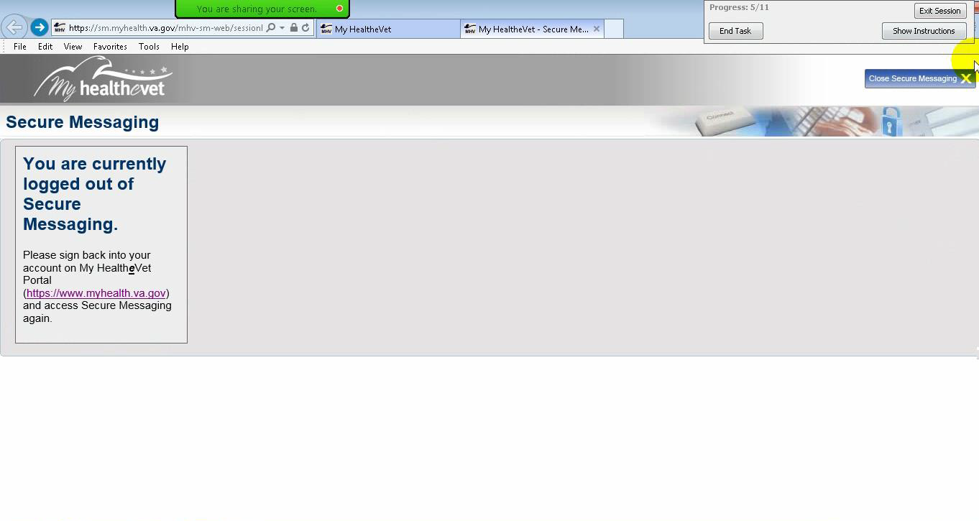

Figure 4: Clicking the “back” navigation button caused participants to be logged out of secure messaging

This issue was rated “Serious” due to a high percentage of task failure and guarantee of navigation issues associated with this error. Using the back function of the browser is standard navigation practice and the error generation is guaranteed to lead to confusion and task frustration.

**Recommendation(s):** This is a core issue of MyHealth*e*Vet functionality. Consider reworking the internal webpage calls of the website to ensure that users don’t receive an error message upon using the Back function to navigate. Additionally, in cases such as Secure Messaging where “Back” would log a user out of a portion of the site, consider providing more specific message instead of the default browser error to help assist the user with context of what they did wrong. Alternatively, give a pop-up dialog warning users they will be logged out.

**8. Clicks “Learn More” boxes on bottom of homepage looking for function:** Participants in 6 out of 15 sessions (40%) attempted to navigate to task function areas of the site via the “Learn More” boxes at the bottom of the homepage.

1. Participant clicks on info box at bottom of homepage looking for refill function
   * 1. P10: “*This is not what I usually see.”*
2. Participant clicks on info box bottom of homepage looking for appointments function
   * 1. P11: *“I had this problem last time looking for appointments.”*
3. Participant clicks on info box bottom of homepage looking for secure messaging function

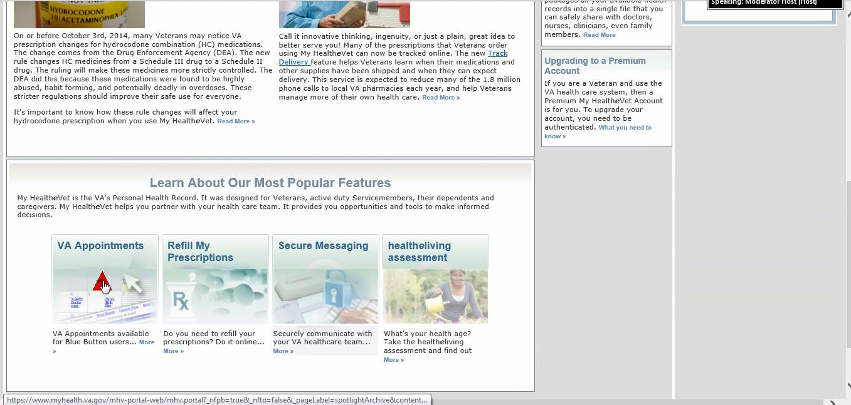

Participants believed Learn More link would lead to appointments function

Figure 5: Mistaking “Learn More” buttons as entry points to ask area

|  |
| --- |
|  |
| Video removed for file size constraints |

Figure 6: Video clip of participant repeatedly clicking on Learn More in attempt to navigate to Appointments.   
**Double click to open in new window**

This issue was rated “Serious” due to the frequency in which it caused errors. In addition, this issue directly impacted three (3) of other six (6) Serious issues. The “Learn More” section contains information regarding very common areas of MyHealth*e*Vet; three of the four selections are Appointments, Rx Refills, and Secure Messaging. Considering the importance of these three features to MyHealth*e*Vet, having them all in the Learn More section is counterintuitive, as it leads to false navigation and frequent frustration.

**Recommendation(s):** The Learn More section should be removed from the homepage and placed somewhere else. While it’s important to have the resources available to the user to inform them of the function of these areas, the current placement results in frequent navigation failure. Also, HFE recommends that each Learn More widget have a link directing the user to the specified area of interest once they are in the selected Learn More subsection.

### Moderate Impact Issues

1. **Difficulty discerning active area for navigation buttons:** Participants in 5 out of 15 sessions (33%) had issues with selecting the proper area of navigation buttons. Errors noted include:
   1. Clicks on text in navigation box (i.e. “Refill My Prescription), expecting whole box to be active area
   2. Tries to click on the city in appointment
   3. Attempts to click on blue button summary in pdf view to get to labs
   4. Repeatedly click on Blue Button icon on homepage
   5. Tries to click on the date in appointment list
   6. Clicks on Blue Button logo at top of generated data page
   7. Clicks on Blue button logo in sidebar
   8. Tries to click on picture of calendar in appointments info page
   9. Tries to click on title in secure messaging entry page

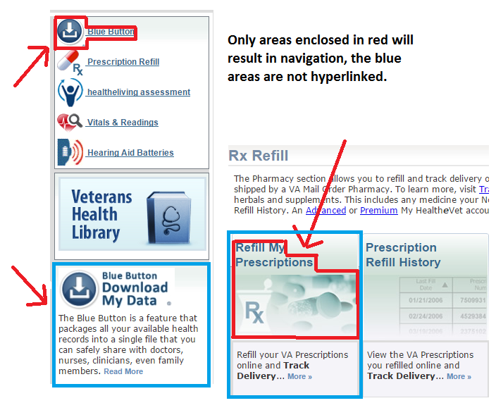

Figure 7: Issue #2: Ambiguous Navigation Boundaries

This issue was rated “Moderate” due to the high frequency of occurrence. There are multiple instances across MyHealth*e*Vet where it looks as though a whole picture could be used for navigation but only a specific portion of it is actively hyperlinked.

**Recommendation(s):** Any areas that could be associated with navigation should be properly hyperlinked to their respective areas in their entirety. Refer to Figure 7 for further elaboration.

1. **Failure to find search function:** Participants in 4 out of 15 sessions (27%) had issues with finding a search function while navigating their Blue Button document or the main website. Examples include:
   1. Looks for/can’t find search function in browser in embedded pdf/Blue Button.
      1. P3 *“I was hoping it would give me instructions about how to do a search here. Usually if I'm in a pdf it has a search right up beside 'edit'."*
      2. P15: "*I'm not sure how easy it would be, but if there's a ton of information, you should have a search function built into this page."* [Browser embedded Blue Button]
   2. Attempts to use a form field as a search box

This issue was rated “Moderate” due to time delay caused by this task and occasional task failure after which recovery is possible.

**Recommendation(s):** Add a clear search function for the Blue Button document in view mode.

### Low Impact Issues

20. Doesn’t place cursor in text field before typing *(27% of participants)*

28. Doesn’t realize they are in a new tab, attempts to return to MHV via back button *(13% of participants)*

38. Button does not register participant’s mouse click *(7% of participants)*

39. Difficulty with size of text (needed screen magnified) *(7% of participants)*

## Login Issues

Four (4) findings, **2** **high impact**, **1 low impact** and **1 testing observation/limitation**, were noted in the Login focus area.



Figure 8: Problem by Participant Matrix: Login Task Area

There was one task associated with the Login focus area. Forty percent (40%) of participants met the success criteria and completed this task within the task time success threshold. In many cases, participants failed due to excessive time spent re-typing credentials after one or more attempts and mistypes. In fact, when the task time threshold is excluded as a success criterion, 80% of participants succeeded. This mistyping issue was ranked as “Not Applicable,” because the credentials were provided as part of the task (see Limitations). As such, the impact of the low success rate for this task is somewhat ameliorated. The majority of participants stated they found the task “very easy”, or “easy”.

Figure 9: Task success and self-assessed difficulty for Login Task

### High Impact Issues

1. **Difficulty finding the login page:** Participants in 3 out of 15 sessions (20%) had issues with finding the login link for MyHealth*e*Vet. Two (2) participants failed the login task due to this issue.
   1. Participant doesn’t notice “Already a Member” widget.
   2. Mousing around MHV homepage looking for login
   3. Navigates to VA homepage looking for login
      1. P6: "*[Expletive deleted], I can't figure out where to logon at."*
   4. Mousing around VA search results page looking for login
      1. P8: "*This is literally killing me."* [repeated over and over under breath]
      2. P8: "*I know that I'm looking at it and I'm missing it. It's frustrating."*

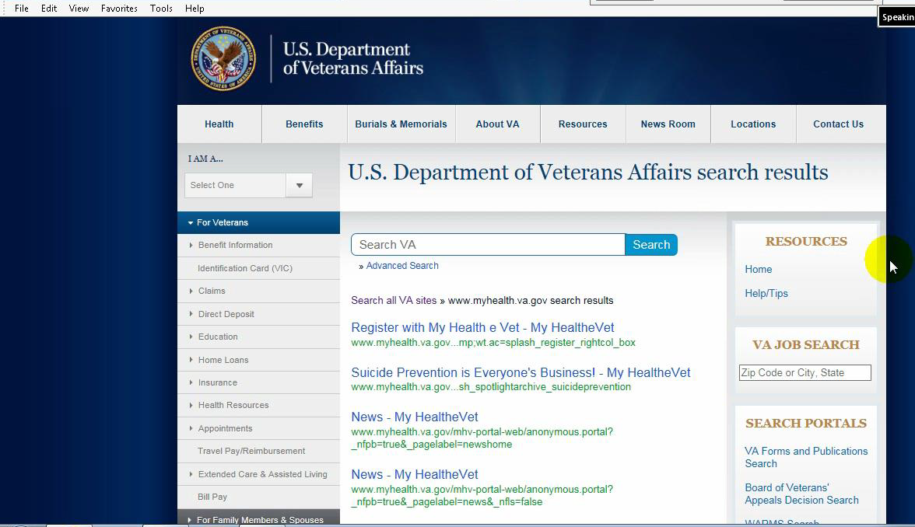

Participants navigated to VA search page looking for the login page

Figure 10: Difficulty finding the login page

|  |
| --- |
|  |
| Video removed for file size constraints |

Figure 11: Video clip of participant navigating to VA homepage while attempting to login.   
**Double click to open in new window**

This issue was rated “Serious” due to it being a precursor to all other tasks. Failure at login would result in abandonment of MyHealth*e*Vet usage.

**Recommendation(s):** Many participants had difficulty with the navigation due to the login being behind the “Already a Member” section. In general, website users are conditioned to look for a text entry area for user-name and password as is found on the MyHealth*e*Vet homepage; not having this on the initial MyHealth*e*Vet page was detrimental to users. Moving the login option to the My Health*e*Vet splash page would increase navigation success. The Not Registered/New User should be a subsection of the login widget as it is on the home page, instead of its own stand-alone widget.

**34. Attempts to login using homepage search bar:** One (1) participant out of 15 (7%) had issues with confusing the search bar on the homepage with an area to enter a username/password. The participant appeared to believe that as the only text-entry field on the page, the search field must be where they should type their credentials.

This issue was rated “Serious” due to login being a precursor for all other tasks.

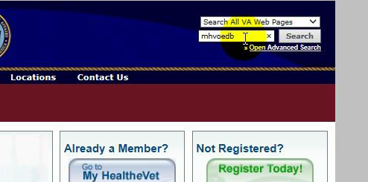

Participants typed provided credentials into search field.

Figure 12: Attempts to login using homepage search bar

|  |
| --- |
|  |
| Video removed for file size constraints |

Figure 13: Video clip of participant attempting to login via the homepage search bar   
**Double click to open in new window**

**Recommendation(s):** Clearly delineate the search bar from the login area as to not confuse users looking for a text-entry zone. Consider moving the login option to the My Health*e*Vet splash page. Consider making the register button a sub-section of the login widget.

### Low Impact Issues:

31. Mistakenly believes self to be logged in. (13% of participants)

### Not Applicable Observations (Test Limitations)

16. Mis-types provided credentials (33% of participants)

## Rx Refill Issues

Seven (7) findings, **3** **high impact**, **1 moderate impact** and **3 low impact**, were noted in the Rx Refill tasks.



Figure 14: Problem by Participant Matrix: Rx Refill Focus Area

Two tasks were associated with the Rx Refill focus area. Twenty percent of participants met the success criteria and task time success threshold for Rx Refill Task 1 (navigate to Rx Refill and identify refillable prescriptions) and 40% did the same for Rx Refill Task 2 (refill acetaminophen). Only one of the nine participants failing Task 2 did so due to not meeting success criteria. Despite low success rates on both tasks, the majority of participants perceived them to be “Very Easy,” or “Easy.” This separation between success and self-assessed difficulty indicates a possible ignorance of task failure for Task 1, where 9 participants indicated an incorrect number of refillable prescriptions.

Figure 15: Task success and self-assessed difficulty for Refill Tasks

### High Impact Issues

1. **Difficulty determining which meds are refillable:** Participants in 10 out of 15 sessions (67%) had issues determining which meds were refillable. This issue caused task failure for 9 of the 10 participants who experienced it.
   1. Thinks only one/two/no med is refillable because of recent refill submission dates. (see Limitations)
      1. Facilitator: How would you know which one is eligible?

P5: "*By the dates, these have recent fill dates, and this one doesn't, so it’s eligible.*"

* + 1. P14: "*How would I know if these are eligible for refill or not? The fill date is 1/16 depending on the type of medication, depending on how soon it would allow me to refill it. So how would I know?”*
    2. Facilitator: If we didn't go by the date, is there anything else that would allow us to know?

P14: *"I just refilled all these on 1/16, so in my opinion they would be ineligible*."

* 1. Clicks submit refill without checking any meds while looking for refillable ones
  2. Clicks submit refill on wrong medication while looking for refillable ones
  3. Doesn’t initially see that the list of meds is also where to refill
  4. Counts all the meds in Rx history page as refillable (all 8)

This issue was rated “Serious” due to frequent task failures and misunderstanding of the language used in this part of the website. Inability to determine which prescriptions are refillable could prevent Veterans from getting their prescriptions refilled when they are needed.

**Recommendation(s):** Many participants used the dates as their identifying factor for whether something was eligible/ineligible for refill. Consider adding a secondary notice (in addition to checkboxes) that a prescription is refillable or making its eligibility clear in the status label terminology to clear up any confusion that may be caused by dates.

**This issue could be due in part to test data that showed that medications had recently been refilled.** See Limitations.

1. **Difficulty navigating to prescription refill:** Participants in 5 out of 15 sessions (33%) had issues with navigating to the Refill My Prescriptions page.
   1. Looks for refills in prescription history
      1. Facilitator: We're really just looking to determine where you would go to see how many are available to refill.

P15: "*From that main screen, it wasn't very clear to me, looking at the top page* [pharmacy page]. *I clicked on prescription refill and then on this screen, refill my prescriptions; I guess I'd go there. In my opinion if you're looking specifically for refills, there should be a menu option to say which prescriptions are available from the pharmacy screen, and take you right there, instead of drilling down to your history to see which ones are active to be refilled.*"

* 1. Mousing over home page looking for refill info/reading news articles in search
  2. Mousing over pharmacy page, unsure where to look for refills
  3. Looks in Medications + Supplements for refills
  4. Clicks on Learn More at bottom of homepage

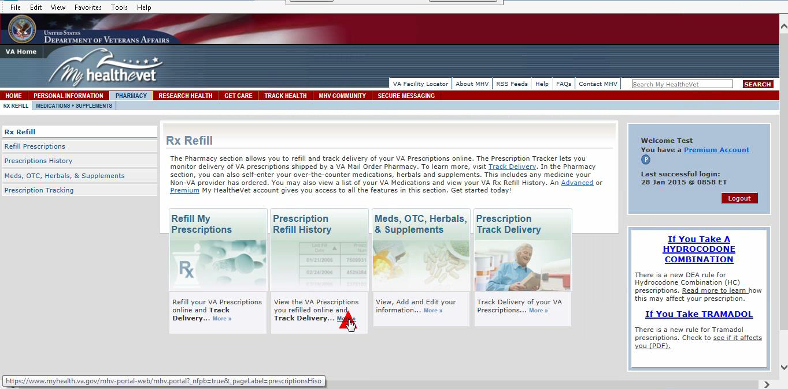

Participants clicked on Prescription Refill History in search for Prescription Refills

Figure 16: Difficulty navigating to Prescription Refill

|  |
| --- |
|  |
| Video removed for file size constraints |

Figure 17: Video clip of participant navigating to Prescription History and Medication + Supplements looking for Prescription refill. Clip also shows participant confusing the terms “active” and “refillable”.   
**Double click .wmv icon to open in new window**

This issue was rated “Serious” due to the frequency of navigation errors and because it impacts a primary usage of MyHealth*e*Vet. Failure to access Rx Refill could result in medications not getting refilled in time or the user not receiving vital information regarding their prescription refill dates.

**Recommendation(s):** Many participants had difficulty with the navigation due to the multiple options available once they reached the Rx Refill main page and the similarity in descriptions on the widgets. Consider making the description on each area more detailed so users aren’t confused by them. Consider adding this main function of the site to the first level of navigation. Consider eliminating entry pages for sections and utilizing drop menus to show content.

1. **Confused by prescription refill language:** Participants in 4 out of 15 sessions (27%) had issues with the specific language on the RX Refill page.
   1. Confused by “fill date” label
   2. Confuses “active” with “refillable.”
      1. P15: "*So, I'm assuming on this screen I'm supposed to count how many are active or refillable? Is that right?"* [While looking at list in Medications + Supplements](see Figure 17 Video Clip)
   3. Clicks through non-refillable prescription in attempt to refill
   4. Difficulty determining which prescriptions are refillable

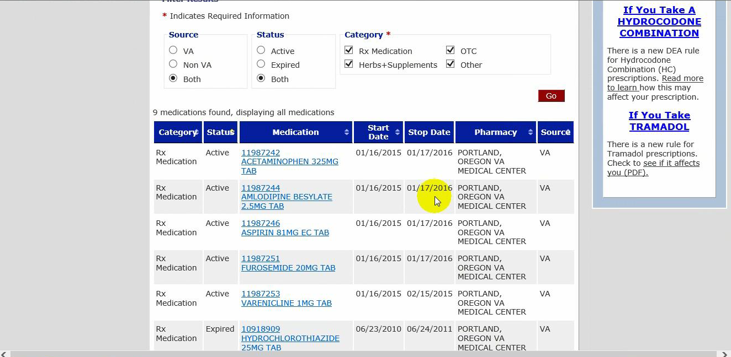

Participants believed   
“Active” status in Medications + Supplements indicated prescription was refillable

Figure 18: Confused by prescription refill language

This issue was rated “Serious” due to it impacting a primary usage of MyHealth*e*Vet and the frequency of errors on this particular task. Failure to identify medications eligible for refill could result in a potential patient safety issue.

**Recommendation(s):** The most significant finding with this task was lack of understanding of the language used on the Refill Prescription page. The labels used to indicate a medication’s status should be re-written to eliminate confusion for the user regarding the following situations:

* Medication is eligible to be refilled.
* Medication is ineligible to be refilled.
* Medicine is one that Veteran should be currently taking
* Medication has already been selected to be refilled and is being processed.
* Medication has no remaining refills and patient must contact their provider if they need a renewal
* Medication is no longer an active prescription, and Veteran should not be currently taking it

### Moderate Impact Issue

**13. Failure to notice refill submitted message or realize refill was submitted:** Participants in 5 out of 15 sessions (33%) had issues with noticing the notification.

* + 1. Facilitator: “What would you want to see?”

P6: "*A little pop-up saying congratulations and the estimated time of delivery.*"

* 1. Confused by error message
  2. Thinks re-submit error message means he hasn’t submitted his prescription for refill
  3. Doesn’t see/register re-submit error message

This issue was rated “Moderate” due to potential confusion with properly submitting medications. Users frequently failed to notice the rather inconspicuous confirmation message.

**Recommendation(s):** The confirmation message upon successfully or unsuccessfully submitting a medication should be much more apparent. Consider using a pop-up dialog box that users must acknowledge or a color box that contrasts more with the visual style of the page.

### Low Impact Issues

40. Notes that refill number should decrement after refill (7% of participants)

41. Believes 0 under “refills remaining” means it needs to be refilled (7% of participants)

42. Refills all of the refillable meds (7% of participants)

## Secure Messaging Issues

Eleven (11) findings, **1** **high impact**, **1 moderate impact** and **8 low impact** (one occurring at a high frequency), were noted in the Secure Messaging focus area.



Figure 19: Problem by Participant Matrix: Secure Messaging Task Focus Area

Two (2) tasks were associated with the Secure Messaging (SM) focus area. Sixty percent (60%) of participants met the success criteria and task time success threshold for SM Task 1 (navigate to secure messaging and read a specific new email), and 53% succeeded in SM Task 2 (send a new message). Participants were mixed in their self-assessment of the difficulty of the two tasks but found the first one more difficult.

Figure 20: Task Success and self-assessed difficulty for Secure Messaging Tasks

### High Impact Issue

1. **Difficulty navigating to Secure Messaging:** Participants in 8 out of 15 sessions (53%) had issues with navigating to the main Secure Messaging page. This caused task failure for 2 participants who could not find the section without moderator prompting.
   1. Participants had general difficulty in finding the page.
      1. P15: "*I don't really see any references to messages, messaging or secure emails*. [while on homepage]
      2. Facilitator: Where do you think there would be an email feature?

P15: "*Well I thought it would be under personal information. That’s what I’m used to seeing.*"

* 1. Participants didn’t notice the “Open Secure Messaging” button on secure messaging entry page
     1. P13: "*I'm lost.*"
  2. Participants clicked navigation links for the following additional areas while searching for the Secure Messaging section:
     1. Learn More
     2. Contact MHV
     3. Personal Information
     4. Get Care
     5. Track Health
     6. Research Health
     7. Pharmacy
     8. Blue Button

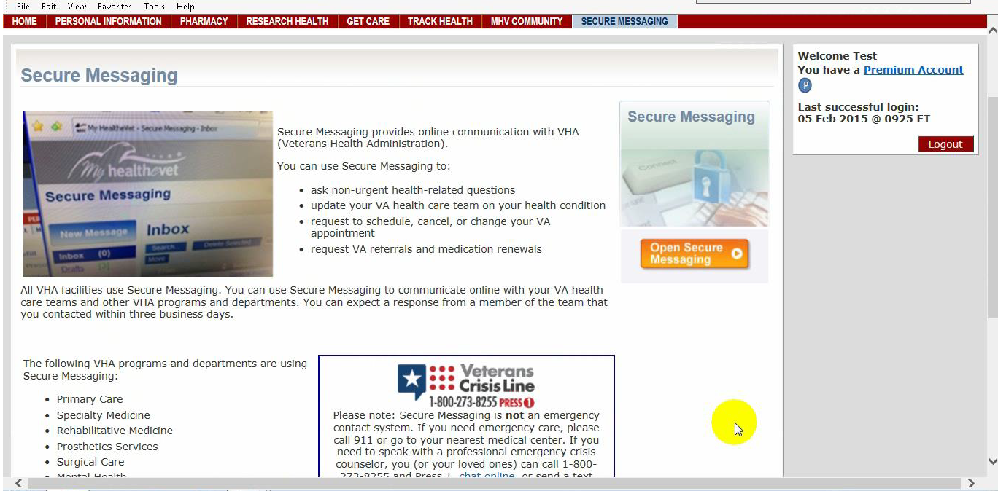

Participants did not see the “Open Secure Messaging” button on the Secure Messaging entry page.

Figure 21: Difficulty Navigating to Secure Messaging

|  |
| --- |
|  |
| Video removed for file size constraints |

Figure 22: Video clip of participant attempting to navigate to Secure Messaging.   
**Double click wmv icon to open in new window**

This issue was rated “Serious” due to a high percentage of task failure and the frequency of navigation errors on this particular task. Failure to access secure messaging could result in a user missing important messages from their pharmacist or provider.

**Recommendation(s):** Many participants had difficulty with the navigation due to it being behind multiple paths and there being many alternate areas one may expect to find it. Despite having the Secure Messaging link in the navigation bar, it is significantly smaller and harder to see in comparison to the other areas participants navigated to. Having to click an additional button after finding the secure messaging main page also was an issue. Considering this is a core functionality of My Health*e*Vet and one of the most commonly used areas, consider placing a widget for Secure Messaging on the front page and removing the interstitial entry page and launch button.

### Moderate Impact Issues

1. **Difficulty finding New Message button in Secure Messaging:** Participants in 3 out of 15 sessions (20%) had issues with creating a new message once they were within Secure Messaging.
   1. Clicks search looking for new message button
   2. Looks in sent box
   3. Looks in draft box looking for way to send new message
      1. P7: *"I guess I'm a little confused on how to send a message here."*

Facilitator: "What types of things would you look for?"

P: "*Well just uh, new message; create new message.*"

This issue was rated “Moderate” due to occasional task failure and user delays.

**Recommendation(s):** Consider changing the language to “Compose Message” instead. Consider making the “Compose Message” button a contrasting color from the text and background styles of the page to better highlight the major function.

### Low Impact Issues

1. Doesn’t change subject line to medication: Participants in 10 out of 15 sessions (67%) had issues with updating the subject line while creating new messages within Secure Messaging.

This issue was rated “Minor” due to its lack of impact on task efficiency.

**Recommendation(s):** The “Subject” line in emails should not be pre-filled to ensure the user selects an appropriate subject.

1. Tries to open email by clicking box in front of it and “read” link (7% of participants)
2. Doesn't click ‘send’ on message (7% of participants)
3. Attempts to create new message by hitting reply (7% of participants)
4. Doesn’t see “send” button (7% of participants)
5. Confused by lack of “Dr.” title in secure message sender information (7% of participants)
6. Wants site to auto-complete typed medications (7% of participants)
7. Searches for new message intended recipient in MHV homepage search field (7% of participants)

## Appointments Issues

Seven (7) findings, **1** **high impact**, **2 moderate impact** , **2 low impact and 2 observations**, were noted in the Appointments focus area.



Figure 23: Problem by Participant Matrix: Appointments Task Focus Area

Two (2) tasks were associated with the Appointments focus area. Twenty-seven percent (27%) of participants met the success criteria and task time success threshold for Appointments Task 1 (navigate to Appointments and determine clinic phone number for next appointment) and 60% successfully accomplished Appointments Task 2 (find last kept appointment). Five (5) of the 7 participants who failed to meet the success criteria for Task 1 chose the wrong future appointment as their “next” appointment (Issue #6 above) and failed to correct their error. This issue, and the difficulty participants experienced in choosing the appointment (Issue #27) were due in part to the limitations of the test data (see Limitations) so were ranked minor despite their effect on task success. Consequently, the impact of the low success rate for this task is somewhat moderated. However, as most participants were unaware of their error, this issue did not affect the self-assessed difficulty of the task.

In the post-task questionnaire, participants expressed frustration with the format of the clinic phone number and the navigational path to appointments:

* P1: *“Needs to be complete phone number*”
* P6: “*One would think the 'My Appointments' tab would have your appointments not newsletters or other information. The Get Care tab is a little confusing considering there already is a My Appointments tab.”*
* P10: “*Finding the appointment link was not very intuitive.”*
* P13: “*Ridiculous to go to VA appointments and not find it there but find directions on where to go to get it.”*
* P14: *“Would be helpful if there was a menu option on the home screen that says My Appointments.”*

Participants accordingly assigned a higher level of difficulty to the Appointments tasks than many of the other tasks.

Figure 24: Task Success and self-assessed difficulty for Appointments Tasks

### High Impact Issues

1. **Difficulty navigating to appointments:** Participants in 9 out of 15 sessions (60%) had issues with navigating to the appointments page.
   1. Participants had general difficulty in locating the page.
      1. P11: *“I know appointments is on here somewhere*.” [Participant was notably proficient with the site and the internet--as noted by his use of the site and his demographics (see session 11 in participant demographics]
      2. P15 "*I don't really see a screen for this. [reads task again] Yeah, I don't see anything on any of the menus referencing appointments*."
      3. P15 " *think it would be much, much easier to have it on this top menu, another icon for this, because I don't see any way as an average user, how to check your appointments. It's not very intuitive*."
   2. Participants were misguided by the Learn More section.
      1. Facilitator: "I notice you went to the Learn More section. What are your thoughts on that?"

P7: "*I was trying; it says your VA appointment in that tab there and then it just gives you the news and stuff, it doesn't give you any appointments. It makes it confusing where it says VA appointments as opposed to 'Get Care.*'"

* 1. Participants clicked navigation links for the following additional areas while searching for the Appointments section.
     1. Personal Information
     2. Wellness Reminders
     3. Track Health
     4. Health*e*Living Assessment
     5. Facility Locator

|  |
| --- |
|  |
| Video removed for file size constraints |

Figure 25: Video clip of participant attempting to navigate to appointments.   
**Double click on wmv icon to open in new window**

This issue was rated “Serious” due to a high percentage of task failure and the frequency of navigation errors on this particular task. Failure to identify appointments creates the potential for users to be uninformed of upcoming appointments and miss important dates.

**Recommendation(s):** Participants struggled to find the Appointments under the ambiguously titled “Get Care” section and searched for it in multiple other sections. Considering this is a core functionality of MyHealth*e*Vet and one of the most commonly used features, consider placing a widget for Appointments onto the front page so that it is easily accessed and including it in the main (first level) navigation of the site.

### Moderate Impact Issues

**14. Difficulty finding kept appointment on second page of appointments list:** Participants in 5 out of 15 sessions (33%) had issues with finding the secondary appointments page.

* + 1. P3 "*You don't have one there that says they kept the appointment.*" “*The only problem was that the next page wasn't showing up on the next screen unless you moved it down. There might be too many lines, I don't know.*”
    2. Facilitator: So in general for appointments, would you prefer a list view or a calendar view?

P7: “*A list view is fine; I just didn't see it on that list*.”

1. Clicks on “personal information” looking for kept appointment
2. Clicks “Track Health” looking for kept appointment
3. Clicks “Health History” looking for kept appointment
4. Decides since he can’t find it, it’s a trick question
5. P10: “*It’s a trick question.”*

This issue was rated “Moderate” due to the frequency of task failure, especially in relation to time taken on task.

**Recommendation(s):** The Next Page function and count of how many are shown (10 out of 20 appointments shown) need to be larger and more apparent.

**19. Failure to find clinic phone number:** Participants in 4 out of 15 sessions (27%) had issues with finding the clinic phone number on appointments.

1. Doesn't recognize clinic phone number as a phone number.
   * 1. P12: "*I don't see a phone number*." [While on page with clinic phone number on it.]
2. Clicks on facility locator looking for phone number
3. Clicks on learn more in appointments looking for phone number

This issue was rated “Moderate” due to occasional task failure after which recovery is possible.

**Recommendation(s):** The “clinic phone” label should be changed to read “clinic extension” and the full phone number for that particular VA facility should also be noted.

### Low impact issues

1. Participant clicks on/chooses wrong appointment: Participants in 7 out of 15 sessions (47%) had issues with locating the correct upcoming appointment
   1. Clicked on next one in the future
   2. Chose an appointment that wasn’t kept

*Note: This could be due in part to test data* *limitations*

This issue was rated “Minor” due to it causing user hesitation and impeding task completion.

**Recommendation(s):** Ensure that appointment dates are clearly delineated.

1. Difficulty finding future/past appointment (test data limitation) (20% of participants)

### Not Applicable Observations

1. Uses health calendar section instead of appointments section

54. Usually uses Blue Button for appointments

## Blue Button Issues

Fourteen (14) findings, **6 moderate impact,** **7 low impact** and **1** observation were noted in the Blue Button focus area.



Figure 26: Problem by Participant Matrix: Blue Button Task Focus Area

Two (2) tasks were associated with the Blue Button focus area. Twenty-seven percent (27%) of participants met the success criteria and task time success threshold for Blue Button Task 1 (navigate to Blue Button and generate Blue Button file for specified data) and 27% succeeded in Blue Button Task 2. In both tasks, when the task time threshold is excluded as a success criterion, 80% of participants succeeded. Difficulties navigating to Blue Button( Issue #15), finding and discerning which file to open (Issue #9 a), opening the file (Issues #29 and #30) and finding the specified data (Issues #10, #36) combined to create long task times that pushed participants over the time success threshold. Participants were mixed in their assessment of the Blue Button Task difficulties.

Figure 27: Task success and self-assessed difficulty for Blue Button Tasks

### Moderate Impact Issues

1. **Hesitation over which blue button download to view/download:** Participants in 6 out of 15 sessions (40%) had issues with selecting a file type on the Blue Button page.
   1. Confusion over various file types.
      1. P6: "*It's got three files. It doesn't tell you what the hell's in any one of them.*"

b. Clicks to download Blue Button and then hit cancel upon app dialogue.

This issue was rated “Moderate” due to general confusion and frequency of task failures associated with the available file types.

**Recommendation(s):** While it is beneficial to have multiple file types available within Blue Button, their differences need to be more readily apparent. The only indication that the files are different is the file extension (.pdf, .txt, .bluebutton) and the indication on the “Download” button. Considering the content of the 3 files is identical, the columns of File Contents, File Name, File Size, and Request Date are less important pieces of information. The different file types should be the first piece of information provided to the user. Additionally, the information above the DOWNLOAD YOUR DATA section should be more easily visible to help users determine which file type they need.

1. **Difficulty navigating to Blue Button:** Participants in 5 out of 15 sessions (33%) had issues finding the area to actually use Blue Button.
   * 1. P15: "*To me, one of the menu buttons should be, download reports. Then you click on it, then you can select date range and then you can pull it up. I see nothing along those lines.*
   1. Navigates to “Get Care/Health Calendar while looking for Blue Button
   2. Navigates to “Get Care/Appointments” while looking for Blue Button
   3. Clicks “Blue Button Features” within Blue button section
   4. Clicks on information link on homepage sidebar
      1. P11: "*Oh, it's smaller than the other one.*" [Upon finding top blue button link, comparing it to blue button logo below that is above the link to the informational page.]
   5. Navigates to “Track Health” while looking for Blue Button
   6. Doesn’t see “continue” button at bottom of Blue Button entry page
      1. P15 *"I don't really see an easy way to download specific reports from this page at all.*"
   7. Clicks on CCD features within Blue Button section

This issue was rated “Moderate” due to the expectation to negatively impact use, the user delays caused, and the occasional failure associated with the task.

**Recommendation(s):** The issues encountered here varied quite a bit and as such there are multiple recommendations. The Blue Button Learn widget should be properly hyperlinked (Figure 6). Once the user reaches the Blue Button page, the next issue is the small visibility of the “Continue” and radio buttons. These need to be made more apparent to the user. Lastly, the “Continue” button should be split into two separate buttons, each grouped in their respective section, depending on if the user wants Blue Button or Health Summary.

1. **Failure to realize Blue Button file is generated/failure to follow through and click to open Blue Button files:** Participants in 2 out of 15 sessions (13%) had issues with realizing their Blue Button file was already generated.
   1. Clicks ‘cancel’ on open pdf dialog
   2. Restarts Blue Button generation on second Blue Button task

This issue was rated “Moderate” due to user delays and occasional task failure that could be recovered from.

**Recommendation(s):** Add a popup that clearly indicates to the user that their Blue Button file has been generated, while elaborating the next steps they should take.

1. **Difficulty opening Blue Button file format (.bluebutton):** Participants in 2 out of 15 sessions (13%) had issues with selecting the correct software to open the .bluebutton file.
   1. Attempts to open Blue Button file download with Adobe Acrobat [Fails to open in Adobe]
   2. Delayed opening in Word (of downloaded Blue Button file) causes confusion/abandonment

This issue was rated “Moderate” due to it occasional task failure, user delays, and an expected negative impact on use.

**Recommendation(s):** Create file type associates to ensure that files open on 1 click if possible. The .bluebutton file format currently shows no recognized opening software despite its ability to open in basic word processing software (MS Word and Notepad included).

1. **Difficulty finding specified data in Blue Button file (not pdf):** Participants in 1 out of 15 sessions (7%) had issues with finding the potassium reading in the Blue Button file.

This issue was rated “Moderate” due to it causing user delays.

**Recommendation(s):** Add a search feature into the Blue Button view mode to assist users with navigating the document. Add clearer segmentation of the generated document, in the form of differentiated sections title styles and section dividers, to assist users with navigating the document.

1. **Difficulty finding lab results in CCD:** Participants in 1 out of 15 sessions (7%) had issues with locating lab results in the CCD file.

This issue was rated “Moderate” due to it causing user delays.

**Recommendation(s):** Add a search feature into the CCD document view mode to assist users with navigating the document.. Add clearer segmentation of the generated document, in the form of differentiated sections title styles and section dividers, to assist users with navigating the document.

### Low Impact Issues

21. Clicked to download health summary instead of blue button (*27%*)

33. Trouble scrolling through Blue Button file (instead of screen page) (*13%*)

50. Doesn’t change the date range (*7%*)

51. Defines incorrect (future) date range in date range picker (Blue Button) (*7%*)

52. Clicks on show all (vs just secure) content link in security pop-up that opens at bottom of Blue Button page (causes page error) (*7%*)

53. Doesn’t see how to generate the selected data in Blue Button (*7%*)

## Veterans Health Library Issues

Three (3) findings, **1 moderate impact,** **1 low impact and** 1 observation, were noted in the Rx Refill focus area.



Figure 28: Problem by Participant Matrix: Veterans Health Library Task Focus Area

One task was associated with the Veterans Health Library focus area (search for medical information on specified topic). Eighty-seven percent (87%) of participants met the success criteria and task time success threshold for the task (find information about cataracts). Notably however, 47% of participants succeeded in this task by navigating to a link that bypassed the Veterans Health Library and brought them to cataract information on the “Medline” website. As such, this task was as much a measure of the participants’ ability to find any kind of information on the My Health*e*Vet website as it was their use of the Veterans Health Library. Participants’ ratings of the difficulty of this task corresponded with the high level of success.

Figure 29: Task success and self-assessed difficulty for Veterans Health Library tasks

### Moderate Impact Issues

1. **Misspellings in VHL search generate no results:** Participants in 1 out of 15 sessions (7%) had issues with VHL giving them no results on search.
   1. This is specific to VHL since MHV compensates for misspelling in search engines.

This issue was rated “Moderate” due to it causing user dissatisfaction and delays with the task.

**Recommendation(s):** Even when typos occur, the search engine should compensate and make suggestions. (“You entered catracts, did you mean cataracts?” with suggested results shown).

### Low Impact Issue

1. Difficulty finding medical information (cataracts) (27 % of participants)

### Not Applicable Observations

1. Finds cataract information via “Medline” (47% of participants)

# User Performance Measures

User performance measures are reported in the table below. Please note that, because of the small sample size, statistical significance cannot be inferred. Detailed performance data are provided in Appendix B: Detailed Performance Data.

* Effectiveness - Objective measures of task success and task failures.
* Efficiency – Objective measures of time on task and number of clicks to complete each task.
* Satisfaction – Subjective measures that express user satisfaction with the ease of use of the site.

|  |  |  |  |  |
| --- | --- | --- | --- | --- |
| **Acceptable?** | **Measure** | **Value** | **Units (averages across all tasks)** |  |
| **Effectiveness** |  |  |  |  |
| No | Effectiveness: Task Success | 44% | Ratio of Task Success (# of successes/# of attempts) |  |
| Yes | Effectiveness: Task Success (Task Time) | 130% | Ratio of Task Time to Benchmark Time (observed time/benchmark time for tasks completed successfully) |  |
| No | Effectiveness: Task Failure | 56% | Ratio of Task Failure (# of failures/# of attempts) |  |
| **Efficiency** |  |  |  |  |
| No | Efficiency: Mouse Clicks | 6 | The mean number of clicks it takes users to complete a task (for tasks completed successfully) |  |
| Yes | Efficiency: Task Time | 130% | Ratio of Task Time to Benchmark Time (observed time/benchmark time for tasks completed successfully) |  |
| **Satisfaction** |  |  |  |  |
| No | Satisfaction: SUS | 64.7 | System Usability Score |  |

Table 3: Performance Measures Overview

# **Satisfaction**

Participants completed the System Usability Scale (SUS) questionnaire (see Appendix E) at the end of their sessions. The SUS is a reliable and valid measure of system satisfaction. SUS scores range from 0 – 100. Sauro reports that the average SUS score from 500 studies across various products e.g., websites, cell phones, enterprise systems and across different industries is a 68. A SUS score above a 68 is considered above average and anything below 68 is below average. Broadly interpreted, scores under 68 represents systems with below average usability; scores over 68 would be considered above average.

The SUS questionnaire measures “perceived ease-of use,” when taken directly after testing or exposure to its subject. It is the participant’s “subjective view of the usability of the system.” It is a measure of the sentiment toward the system, not the objective experience. Participants can and will rate something as easy after consistently failing tasks (this has been found to happen 14% of the time). As such, the SUS is not diagnostic and should not be taken out of context of the other usability metrics collected during testing.

Based on the SUS findings collected during the usability test session, subjective satisfaction with the system (based on performance of tasks in the session) was **64.7 (SD=9.3).** Scores ranged considerably from test to test and there were six outliers, with extremely low and high SUS scores. The SUS score including these outliers was 65.8 (SD=15.7). **This SUS score indicates a below average satisfaction ranking.**

Figure 30: System Usability Scale (SUS) scatter plot

The SUS scores were examined against participant demographics to determine if self-assessed familiarity with desktop computers and/or usage of the MyHealth*eV*et website correlated with the participants’ level of satisfaction with the site.

|  |  |  |  |
| --- | --- | --- | --- |
| **Session/Participant** | **SUS Score** | **How often do you use MyHealtheVet?** | **What is your level of familiarity with using a Desktop computer?** |
| Session 1 | 87.5 | Daily | Advanced |
| Session 2 | 65 | Monthly | Intermediate |
| Session 3 | 92.5 | Weekly | Intermediate |
| Session 4 | 50 | Weekly | Intermediate |
| Session 5 | 80 | Weekly | Intermediate |
| Session 6 | 52.5 | Rarely or Never | Intermediate |
| Session 7 | 65 | Monthly | Intermediate |
| Session 8 | 57.5 | Rarely or Never | Intermediate |
| Session 9 | 40 | Weekly | Intermediate |
| Session 10 | 62.5 | Monthly | Advanced |
| Session 11 | 52.5 | Monthly | Advanced |
| Session 12 | 77.5 | Monthly | Advanced |
| Session 13 | 87.5 | Monthly | Intermediate |
| Session 14 | 70 | Monthly | Advanced |
| Session 15 | 47.5 | Rarely or Never | Intermediate |

Table 4: SUS Score and Technology/MHV familiarity comparison

While the participant SUS scores do not seem to correlate to their familiarity with desktop computer usage, it does correlate slightly with their frequency of My Health*e*Vet use. The SUS may be varying according to a learning curve; participants are more satisfied with the site if they have used it often and are familiar with it. It is also possible that some participants use My Health*e*Vet to accomplish a particular task(s) such as Rx Refill which they have developed proficiency at doing. During this usability test, participants were asked to perform a variety of tasks that they may have not done previously. Their unfamiliarity with certain My Health*e*Vet features also may have influenced SUS scores.

# Perceived Utility

Figure 31: Did the My HealtheVet website meet your expectations?

One of the measures captured was user perspectives regarding the utility of the MHV task functions. Thirteen (13) out of 15 participants answered “yes,” to the closing question asking if the website meets their expectations, but their written comments explaining why they felt that way revealed more ambiguity.

* P1: *“I use it often and can usually find what I need there.”*
* P2: “*I think that I’ll need to get familiar with the site.”*
* P4: *Eventually I am able to find the information I am looking for, it is hidden behind tabs of a different name, remembering where you went the last time you were online versus direct access*
* P5: *Yes, redundant in some ways but eventually you get there. Just like VA*
* P6: “*Needs to be more user- friendly. Not all Vets are good with computers*.”
* P8: “*Because it’s to help the vets that use it, so they try to make it as helpful as possible and with all the information they can get*.”
* P9: “*Having used my health Vet before I was somewhat familiar with it but for someone who doesn't use it regularly it has you chasing form one section to another to reach the area you want. Not everyone is computer literate and will get frustrated with having to go back and forth from one area to another.”*
* P10: “*I just need some training and time to play with the site.”*
* P11: “*It is a great site to keep track of all my VA healthcare information, and be able to easily ask questions to my healthcare team in a non-emergency situation.”*
* P12: “*It just takes some time to get back into how the website is set up since I have to use other sites for my wife’s information.”*
* P14: “*Was able to complete anything I needed to once I understood how to get to it”*
* *P15: “Was difficult to perform some functions*.”

Participants expressed a need for time and training to become familiar with and easily use the site. The comments reveal that the participants’ perception of utility is in large part aspirational. It reflects a belief they could learn to use the site someday, not their recently completed use of it.

Figure 32: Do you feel the content of the website could be useful to you?

The large majority replied, “Yes” when asked if they felt the My Health*e*Vet website could be useful to them. Their comments in response to the question are straight-forward; they need the functions contained in the site. However, participants still hedged their answers with hesitation about their current ability to use the site.

* P1: *“I can usually find what I need but not always.”*
* P5: *“I use it to refill most of my prescriptions.”*
* P7: *“I am sure it is as it is with anything, the more you use the website the more you are able to locate items and the easier it becomes.”*
* P8: *“Because I don't know if I will ever use it any time soon. But maybe in the future.”*  
  P9: “*It is very useful to be able to obtain the information that you need without having to call 6 different departments to get it.*”
* P11: “*It’s a great 'one-stop' site for all the info and tools that I need*.”
* P12 “*It allows a veteran to actually track their health issues as well as the status of each item. We just need to use it more*.”
* P14 “*Gives me a great location to obtain information*”
* P15 “*The site has some very useful data*.”

Figure 33: Would you recommend the My HealtheVet website to other Veterans?

Again, participants responded positively when asked if they would recommend the site to other Veterans, with 14 out of 15 participants responding “yes.” However, the comments again expressed reservations about the usability of the site. Participants are unsure if the Veterans to whom they recommend it would be able to use it without assistance.

* P1: *“I do recommend it often to others because it will answer most questions one may have about treatment or medications.”*
* P2: *“Just need to have a class for instructions.”*
* P5: *“Have assisted several local vets to get them used to using it.”*
* P6: *“It’s the front door to help.”*
* P7: *“Probably not older vets who are not used to using the computer*.”
* P8*: “If I see a vet that’s really in need of this website, I will tell them about it. It is very important.”*
* P9: “*I have found it very useful to have my appointments and records available to me at any time that I need to access them.”*
* P12: *“As I just mentioned in the question before. It can be an asset if we only use it for our best advantage.”*
* P14: “*However, I would have to sit down with them at least once to show them how to navigate it.”*

Overall, participants are very certain of the utility of the My Health*e*Vet website. However their positive answers are caveated by comments that reflect their low task success rates. While participants think the site to be useful and necessary, they experience difficulties using it and believe it would take them time to learn to use it well.

# **Limitations**

Due to the challenges of using test accounts and data in an personal health record website, there were significant limitations for this study. In some instances these limitations contributed, in varying degrees, to issues that had impact on task success.

## General Study Design Limitations

Users were directed to return to the My Health*e*Vet home screen between task focus areas. This was done to enable easier A/B comparisons to later designs of the site, which may have different information architecture. Due to this study design, participants may have used different navigation strategies than those of a more natural, story-line based script. This study design limitation did not contribute to any issues noted in this report.

## Login Test Data Limitations

Thirty-three percent (33%) of participants mistyped the provided test account credentials at least once in the login task (see issue #12 in Login Not Applicable Observations). The requirement for participants to type credentials they had never before used necessarily made the task a benchmark for a user’s first time logging in, rather than a benchmark of a user logging in with credentials they are accustomed to typing.

Additionally, the provided passwords were a mixture of upper-case letters, a symbol and numbers. This may have contributed to user typing errors as users are more accustomed to a mixture of upper- and lower-case letters. Four participants compensated for this by using caps lock to type the password.

Mis-typing the provided credentials may have contributed to a moderate degree to the low success rate for this task due to task time.

## Rx Refill Test Data Limitations

Three (3) test accounts were used for the usability testing. These accounts sent the participant submitted Rx Refill and Secure Messaging data to pre-designated doctors and pharmacists. These clinicians then reset the prescription and secure messaging data each night to ensure identical experiences for each participant. However, this process resulted in prescriptions that, while refillable, showed that they had also been refilled the day before. When participants expressed confusion about the dates, the facilitator prompted them to look for other ways to determine which prescriptions were available to refill. This test data limitation likely contributed to issue #1 (Difficulty determining which meds are refillable) in Rx Refill High Impact Issues) and in some cases may have had a low degree of impact on task failure for Rx Refill Task 1.

Occasionally the participant-submitted refills did not reach the supporting pharmacist in time for a reset prior to the next participant. In these cases, the facilitator prompted the participant to refill a different prescription from the one in their task scenario. This prescription substitution did not contribute to any issues noted in this report.

## Appointments Test Data Limitations

The labels and content of the Appointments section were constricted by the limitations of the test data and did not completely match what an actual Veteran user of the site would see.

Fake clinics, “Jim B’s Fake Clinic-Area AA,” and “Fake Clinic” were used in place of actual VA Clinics. This limited the attempts of some users to find the clinic phone number using the facility locator. Additionally, “Fake Clinic” did not have a clinic phone number in the first two task sessions. The facilitator prompted participants to indicate where they believed they would find it. This limitation contributed to issue #4 (Failure to find clinic phone number) in Login Moderate Impact Issues and may have had very low degree of impact on task failure.

Future appointments were labeled “Not Applicable” instead of “Future.” This was a limitation of the test data. The facilitator prompted participants to ignore the “Not Applicable” labels and go by dates, but participants looking for the next appointment expressed confusion over the lack of a “Future” label. This limitation contributed to issue #6 (Participant clicks on/chooses wrong appointment) and #26 (Difficulty finding future/past appointment) in Appointment Low Impact Issues and may have had a moderate degree of impact on task failure for Appointment Task 1.

## Secure Messaging Test Data Limitations

Users of My Health*e*Vet are able to send secure messages to any clinic of which they have been a patient. In many instances this results in a long drop-down of choices in the “To:” field of the new message composition screen. The three test accounts were only assigned one or two clinics. This limited the ability to test participants’ use of the “To:” dropdown, as the default selection, “MHV Test Triage Group” was the one specified in Secure Messaging Task 2. This test account limitation did not contribute to any issues noted in this report.

# Conclusion

In this study, the current version of My Health*e*Vet scored poorly in effectiveness, below average in efficiency and below average in satisfaction. The task success rate was low at 44%, with participants failing 56% of all tasks attempted. Participants failed 68 out of the total 150 tasks performed (over the course of 15 sessions) due to exceeding the task time success threshold (benchmark time + 100%). Participants who did succeed did so 30% slower than the benchmark time, which is acceptable. However, taking task failure due to task time into consideration, the site cannot be considered effective by any of the recorded metrics.

The site performed below average in efficiency. Participants who successfully completed tasks, on average, used 6 mouse clicks to complete each task. While one of the Blue Button tasks could take as many as 8 clicks to optimally perform, the other 9 tasks would optimally require 2-3, making this a high average overall for the successful tasks. Again the measure of task time for successfully completed tasks is considered efficient, but diminished by the low number of tasks successfully performed in the given time frame.

Finally, the site received a below average SUS score of 64.7, the measure of participants’ satisfaction with the site. This score, while near the average score of 68, should also be considered in light of the participants’ replies to utility portions of the closing questionnaire. As noted in the perceived utility section, participants consistently rated the site high for meeting expectations and likeliness to use, and then countered those scores with comments doubting their ability, and the ability of other veterans, to use the site.

As mentioned, lengthy task times contributed to a high failure rate, due in part to multiple usability issues that repeatedly caused participants to exceed the task time success threshold. Overall, HFE observed and coded 54 issues in this study, 9 of which were considered serious. Participants experienced the most difficulty with the Rx Refill tasks, despite ranking it the easiest task in post-task questionnaires. HFE noted 7 usability issues in the Rx Refill focus area, 3 serious, including the most frequent issue of the study - difficulty determining which meds were refillable. Blue Button caused the second most difficulty, despite its lack of serious issues. HFE noted 14 total issues in the two Blue Button tasks, the highest among the task focus areas. Participants described it as the most difficult in post-task questionnaires. Four (4) of the 9 serious issues related to navigation within the site. Many participants attempted to complete tasks through the “Learn More” boxes at the bottom of the MHV homepage. This contributed to task failure in nearly every task in this study.

HFE recommends specific focus on the terminology and information architecture for the redesign of MHV. Navigation to Rx Refill, Secure Messaging, Appointments, Blue Button, and Logon caused serious problems for multiple participants. As the most used components of the health portal, they should all be part of the first level of menu items and easily accessible from the home page, preferably in the form of an upfront widget requiring no sub-navigation.

A dashboard configuration of these widgets and snapshots of their related content would allow users to view all their main functions at a glance and prevent many navigational issues. Furthermore, whenever possible, limit interstitial entry and launch pages to functions. Consider utilizing dropdown menus or other methods of displaying section sub-content. Consider limiting or eliminating large informational blocks, such as the bottom “Learn More” sections, from the homepage, as participants consistently confused them as direct links to the functions. Instead, create a separate help section accessible from the main navigation, with informational screens that also link directly to the functions described. Consider updating all Rx Refill language to clearly state in plain language the various statuses of the Veteran prescriptions. Finally, HFE recommends iterative usability testing during all stages of redesign development, including wireframes, to ensure adherence to human factors guidelines and standards.

# Appendix A: Participant Demographics and Background Information

Participant demographics are reported in the table below.



|  |  |  |  |  |  |  |  |  |
| --- | --- | --- | --- | --- | --- | --- | --- | --- |
| *Which task(s) do you commonly use MyHealtheVet for?* | | | | | | | | |
| Participant | **Prescription Refill** | **Secure Messaging** | **Appointments** | **Blue Button** | **Veterans Health Library** | **Other:** | **Comment** |
| Session 1 | X | X | X | X |  |  |  |
| Session 2 | X |  | X |  |  |  |  |
| Session 3 | X | X |  | X |  |  |  |
| Session 4 | X | X | X | X |  |  |  |
| Session 5 | X |  |  | X | X |  |  |
| Session 6 |  |  |  |  | X |  |  |
| Session 7 |  |  |  |  |  | X | Lab results |
| Session 8 |  |  |  |  |  | X | none |
| Session 9 | X | X | X |  |  |  |  |
| Session 10 | X |  |  |  |  |  |  |
| Session 11 |  | X | X |  |  |  |  |
| Session 12 | X |  | X | X | X |  |  |
| Session 13 | X |  |  |  | X |  |  |
| Session 14 |  | X |  |  | X |  |  |
| Session 15 |  |  |  |  |  | X | New User |

# Appendix B: Detailed Performance Data

Complete data collected during the sessions and/or generated via analysis, may be found in the master data workbook:



This workbook includes:

* Results Summary for all successful attempts
* Summary of metrics by task
* Table of total HFE standard metrics
* Total task success metrics, and task success metrics broken down by success criteria and success time
* Task times and calculations of task time success threshold
* Complete findings (weaknesses and strengths) along with frequency in the form of a “Problem by Session” matrix (as marked from manual notes and Morae™ recordings)
  + The findings were compiled into the “problem matrix”[3] in order to analyze frequency, with the sessions on the x axis and the issues listed on the y axis. Issues on the y axis are listed in descending order of frequency. When issues were repeated by participants during the same focus group, the number of times the issue was encountered is included in the corresponding cell.
* Problem by task metrics
* Performance charts (task success, task time, mouse clicks) for success only and all attempts
* Charts displaying questionnaire data (opening, post-task and closing)
* Raw questionnaire answers (opening, post-task and closing)
* Raw mouse click data
* Raw SUS scores, SUS calculations, scatter plot and comparison table by desktop and MHV use
* Participant Demographics

If you would like help interpreting any of the data contained in the Master Data Workbook, please contact the study authors for a walkthrough session.

# Appendix C: Study Scripts

**Test Script**

Thank you for your willingness to provide feedback on MyHealth*e*Vet and its various components. In the coming months a re-design of MyHealth*e*Vet will take place. The goal of today’s session is to test the current website so that we can obtain an understanding of how easy it is to use and how satisfied Veterans are with it. All together testing will take no more than 1 hour. I am your facilitator, William Plew, from Human Factors Engineering.

This is a test of the MyHealtheVet website, not a test of your performance. The purpose is to discover improvements that can be made prior to re-design of the website. There are no wrong answers to any of the questions. We appreciate any comments and if you have questions, feel free to ask although I can’t help directly with the tasks.

Your participation is completely voluntary and you may withdraw at any time. Your feedback is kept confidential; your name will not be associated with any comments or results. Do you have any questions for me before we get started?

We would like to record today’s session. The recordings will be kept on a secure server with access provided only to project team members.

***\*\*Begin recording*: Actions -> Morae Recording & Webex\*\***

Now that we’re on record, once again do I have your permission to record? Thank you. There will be three main parts in today’s test. First we’ll begin with a brief questionnaire, then we’ll perform a few common tasks in MyHealth*e*Vet, and lastly we’ll wrap up with a short questionnaire and usability survey. There will be a few different key areas we’ll look at in today’s evaluation. You can start each task by clicking the Start Task button on the prompt up above. After you complete each task, please hit the End Task button and you will be asked a short question regarding the task. If at any time you need to view the instructions again you can use the Show Instructions button to expand or minimize them. Whenever you’re ready to begin please click the Start button on the screen. Do you have any final questions before you begin?

***Participant to answer in Morae via an Opening Questionnaire:***

### Opening Questionnaire

*The following questions are included in the questionnaire presented via Morae.*

We will begin with some background questions about you. Please take your time and if you have any questions you are welcome to ask me for help.

You should see a questionnaire on the screen. Please complete it.

1. Gender: □ Male □ Female
2. Age Range: □ 20s □ 30s □ 40s □ 50s □ 60s □ 70s or older
3. How often do you use MyHealth*e*Vet? □ Daily □ Weekly □ Monthly □ Rarely or Never
4. Which task(s) do you commonly use MyHealth*e*Vet for: □ Prescription Refill □ Secure Messaging □ Appointments □ Blue Button □ Veterans Health Library □ Other:
5. What is your level of familiarity with the following technologies?
   1. Desktop □ Basic □ Intermediate □ Advanced
   2. Laptop □ Basic □ Intermediate □ Advanced
   3. Tablet □ Basic □ Intermediate □ Advanced
   4. Smart Phone □ Basic □ Intermediate □ Advanced
6. If familiar with Tablet or Smart Phone: Approximately how many mobile apps have you downloaded? (Open Answer)
7. Do you require any assistive technologies (e.g., a screen reader) when using a computer?

□ Yes □ No

1. If “Yes”, please describe:
2. Do we have your permission to record your voice and screen interactions? □ Yes □ No

Alright, at this point the prompts will fully guide you through the exercise. I will be right here in the event that you need any technical help, but I cannot assist with navigation. Please take your time and complete the tasks at a pace that you’re comfortable with.

***Participant will now proceed through and complete the MHV navigation tasks.***

*The following tasks and questionnaire prompts are included in the questionnaire presented via Morae.*

**Section 1: MHV Logon**

*Task:* You just remembered that you had a couple of tasks that need to be accomplished within MyHealtheVet. Please go ahead and login to your account with the provided credentials.

*Success Criteria (1:17):*

* Selects “Go to My HealtheVet” Button > Enters user ID/password to login on right side of the screen.
* Completes task within the allotted task time.

*Failure Criteria:*

* “Go to My HealtheVet” is never selected.
* Participant is unable to find the User ID/Password section.
* Participant exceeds the allotted task time.

*Questionnaire Prompts:*

* Please rate the difficulty of the task you just completed.
  + Very Easy – Easy – Neutral – Difficult - Very Difficult
* Was there anything about this task that you found confusing or difficult? If so please elaborate.
  + Yes (Open-ended box added)
  + No

**Section 2: Rx Refill**

*Task:* You have been meaning to see if any of your medications are available for refill. Please determine if any meds are eligible for refill at this time and make sure to note how many are available for refill (if any).

*Success Criteria (1:20):*

* Locates the RxRefill page and determine what is eligible for a refill
* Completes task within the allotted task time.

*Failure Criteria:*

* Inability to navigate to the RxRefill sub-page.
* Inability to locate refillable medications
* Exceeds the allotted task time.

*Questionnaire Prompts:*

* Did you find any meds that were eligible for refill? If so how many were eligible?
  + Yes (Open-ended box added)
  + No
* Please rate the difficulty of the task you just completed.
  + Very Easy – Easy – Neutral – Difficult - Very Difficult
* Was there anything about this task that you found confusing or difficult? If so please elaborate.
  + Yes (Open-ended box added)
  + No

**[If no medications are available for refill, ask the participant what they would look for to indicate that a refill would be available]**

**“Please navigate to where you think you’d find medications and refills and describe for me what you’d expect to see informing you that a med is eligible for a refill.”**

*Task:* Please go ahead and request a refill for acetaminophen and make sure to note how many refills are remaining.

S*uccess Criteria (0:26):*

* Selects Prescription Refill widget > Refill My Prescriptions > Selects the proper Rx for refill (acetaminophen).
* Refills acetaminophen.
* Properly notes the number of remaining refills.
* Completes task within the allotted task time.

*Failure Criteria:*

* Inability to navigate to the RxRefill sub-page.
* Refills the incorrect medication.
* Reports the incorrect number of refills
* Exceeds the allotted task time.

*Questionnaire Prompts:*

* Please rate the difficulty of the task you just completed.
  + Very Easy – Easy – Neutral – Difficult - Very Difficult
* How many refills were remaining on the prescription?
  + (Open-ended)
* Was there anything about this task that you found confusing or difficult? If so please elaborate.
  + Yes (Open-ended box added)
  + No

**[If acetaminophen isn’t available for refill, ask the participant to refill a different medication that is available. If none are available, ask they how they think they would request a refill]**

**“Considering what you just told me, how do you think you would request a refill from this page?”**

**Section 3: Secure Messaging**

*Task:* Please return to the MyHealtheVet Home Page before clicking Start Task.

Now that you’ve requested the refill, you wanted to touch base with the pharmacist regarding a new prescription that wasn’t on your Refill page. Check to see if you have any new messages from Dr. Douglas and open them if you do.

*Success Criteria (2:33):*

* Selects Secure Messaging in the top navigation bar > Selects “Open Secure Messaging” widget. Navigates to Inbox > Finds Dr. Douglas’s most recent message.
* Locates Secure Messaging page through search function, Finds Dr. Douglas’s most recent message.
* Completes task within the allotted task time.

*Failure Criteria:*

* Inability to locate Secure Messaging.
* Never finds Dr. Douglas’s most recent message.
* Exceeds the allotted task time.

*Questionnaire Prompts:*

* Please rate the difficulty of the task you just completed.
  + Very Easy – Easy – Neutral – Difficult - Very Difficult
* Was there anything about this task that you found confusing or difficult? If so please elaborate.
  + Yes (Open-ended box added)
  + No

**[If the message is not flagged as unopened, have the participant locate the most recent message from Dr. Douglas.]**

**“Next I’d like for you to navigate to messages and find the most recent message from Dr. Douglas.”**

*Task:*  You've decided that you want to send a new message regarding a prescription you’ve been waiting for, compose a new message to the Test Triage Group and ask them about a new prescription for ibuprofen.

*Success Criteria (1:36):*

* Selects New Message > Selects Pharmacy clinic > Selects “Medication” as the Subject > Composes a message regarding the ibuprofen.
* Completes task within the allotted task time.

*Failure Criteria:*

* Inability to create a new message.
* Inability to locate the correct clinic.
* Exceeds the allotted task time.

*Questionnaire Prompts:*

* Please rate the difficulty of the task you just completed.
  + Very Easy – Easy – Neutral – Difficult - Very Difficult
* Did you update the subject line to Medication?
  + Yes
  + No
* Was there anything about this task that you found confusing or difficult? If so please elaborate.
  + Yes (Open-ended box added)
  + No

**Section 4: Appointments**

*Task:* Please return to the MyHealtheVet Home Page before clicking Start Task.

Now that we’ve sent our message, let’s check appointments to see the next time you have a VA facility visit scheduled. You’ll want to find the clinic phone number for the visit as well.

*Success Criteria (3:05):*

* Selects Get Care in top navigation bar > Selects VA Appointments widget or Appointments in secondary nav bar > Locates next upcoming appointment > Locates “Clinic Phone” on the appropriate visit.
* Locates Appointments page through search function > Locates “Clinic Phone” on the appropriate visit.
* Completes task within the allotted time

*Failure Criteria:*

* Inability to navigate to Appointments page.
* Inability to find the next upcoming appointment.
* Failure to locate the Clinic Phone number.
* Exceeds the allotted task time.

*Questionnaire Prompts:*

* Please rate the difficulty of the task you just completed.
  + Very Easy – Easy – Neutral – Difficult - Very Difficult
* Did you find the clinic phone? Please type it in if you did.
  + Yes (Open-ended box added)
  + No
* Was there anything about this task that you found confusing or difficult? If so please elaborate.
  + Yes (Open-ended box added)
  + No

*Task:* Now please determine the last time you visited the VA facility and note the date of the visit.

*Success Criteria (1:50):*

* Locates last confirmed appointment > Locates “Clinic Phone” on the appropriate visit.
* Completes task within the allotted time

*Failure Criteria:*

* Inability to find the last confirmed appointment.
* Failure to locate the Clinic Phone number.
* Exceeds the allotted task time.

*Questionnaire Prompts:*

* Please rate the difficulty of the task you just completed.
  + Very Easy – Easy – Neutral – Difficult - Very Difficult
* Did you find the date of your last visit? Please type it in if you did.
  + Yes (Open-ended box added)
  + No
* Was there anything about this task that you found confusing or difficult? If so please elaborate.
  + Yes (Open-ended box added)
  + No

**Section 5: Blue Button**

*Task:* Please return to the MyHealtheVet Home Page before clicking Start Task.

In preparation for an appointment you have with a doctor in private practice, I’d like for you to navigate to Blue Button and download the following records for a range of 3 months: Future VA Appointments, VA Laboratory Results, VA Allergies, and VA Vitals and Readings.

***Facilitator prompts to expand question for reference***

*Success Criteria (2:00):*

* Selects Blue Button widget on homepage > Selects “Download my customized Blue Button data” > Selects 3 months date range > Selects specified items.
* Locates Blue Button page through search function > Downloads specified data.
* Completes task within the allotted task time.

*Failure Criteria:*

* Inability to navigate to Blue Button page.
* Failure to select appropriate date range.
* Failure to download specified criteria.
* Exceeds the allotted task time.

*Questionnaire Prompts:*

* Please rate the difficulty of the task you just completed.
  + Very Easy – Easy – Neutral – Difficult - Very Difficult
* Did you set the date range to 3 months?
  + Yes
  + No
* Was there anything about this task that you found confusing or difficult? If so please elaborate.
  + Yes (Open-ended box added)
  + No

*Task:* On our Blue Button download, please locate the lab result for your potassium reading.

*Success Criteria (1:54):*

* Locates the potassium lab reading.
* Completes task within the allotted task time.

*Failure Criteria:*

* Inability to locate potassium lab reading
* Exceeds the allotted task time.

*Questionnaire Prompts:*

* Please rate the difficulty of the task you just completed.
  + Very Easy – Easy – Neutral – Difficult - Very Difficult
* Was there anything about this task that you found confusing or difficult? If so please elaborate.
  + Yes (Open-ended box added)
  + No

**Section 6: Veterans Health Library**

*Task:* Please return to the MyHealtheVet Home Page before clicking Start Task.

You’re worried about your eye sight lately and want to do some research. Please find some information on Cataracts on the MVH site.

*Success Criteria (2:27):*

* Selects Veterans Health Library widget > Selects Diseases and Conditions > Selects Eye Problems > Selects “What Are Cataracts?”
* Locates the “What Are Cataracts” entry through searching.
* Completes task within the allotted task time.

*Failure Criteria:*

* Inability to locate the Veterans Health Library.
* Inability to locate the “What Are Cataracts?” entry.
* Exceeds the allotted task time.

*Questionnaire Prompts:*

* Please rate the difficulty of the task you just completed.
  + Very Easy – Easy – Neutral – Difficult - Very Difficult
* Was there anything about this task that you found confusing or difficult? If so please elaborate.
  + Yes (Open-ended box added)
  + No

### Closing Questionnaire

*The following questions are included in the questionnaire presented via Morae and will immediately display after the completion of task and the SUS test.*

#### Prompt that they can still view the site by moving survey to the side.

You should now see a second questionnaire on the screen. Please complete the questionnaire.

1. What was your overall impression of the My Health*e*Vet site?
2. Which section did you find it easiest to perform tasks in?

□ Login □ Prescription Refill □ Secure Messaging □ Appointments □ Blue Button

□ Veterans Health Library

Why?

1. Which section did you find the most difficult to perform tasks in?

□ Login □ Prescription Refill □ Secure Messaging □ Appointments □ Blue Button

□ Veterans Health Library

Why?

1. Were there any features that you were surprised to see?

□ Yes □ No

If Yes, what features were surprising?

1. Was there anything missing in this website?

□ Yes □ No

If Yes, what features would you like to have that you did not see?

1. In general, did the website meet your expectations? □ Yes □ No

Why or why not? If no, what could be improved to change that?

1. Overall, do you feel the content of the website could be useful to you? Please elaborate why you feel that way. □ Yes □ No
2. Would you recommend this website to other Veterans? Please elaborate for us. □ Yes □ Maybe □ No

## Closing

This concludes our session today.

*The Support Staff will save the file as Session <X>and ensure that the correct participant type and sequence is reflected in the file name.*

We will be combining your feedback with that of other Veterans who participate in this study. When all of the sessions are complete, we will be delivering a final report on MyHealth*e*Vet tasks you and others completed.

Once again, thank you for participating today. Your feedback is invaluable in helping us to identify navigation issues with these common tasks. It will be helpful in assisting us with the upcoming redesign of the website to help make it faster and easier to use. If you have any additional feedback after our session today that you would like me to consider for inclusion in the final report, please feel free to email me.

I would like to ask you one more favor before we finish up. Later today you will receive an email from JD Power with links to one last questionnaire. In an effort to continually improve how Human Factors Engineering conducts studies, we would like your feedback on the session carried out by our team today, including my facilitation. The email from me will include a link to a questionnaire to gather that feedback. It is very short, including only a handful of questions, and should only take a minute or two. There will be a code in the email that you should use in the questionnaire to differentiate this study from other studies currently underway by Human Factors Engineering. The code won’t identify you as a participant, but identify that you were a part of this specific study.

Do you have any remaining questions or comments for me today? Thank you again and have a fantastic day!

*Moderator contacts Gordon to reset test environment:* [*gordon.wong5@va.gov*](mailto:gordon.wong5@va.gov)

# Appendix D: Issue Ranking System



# Appendix E: System Usability S

**System Usability Scale**

© Digital Equipment Corporation, 1986.

|  |  |  |  |  |  |
| --- | --- | --- | --- | --- | --- |
|  | Strongly Disagree |  | Neutral |  | Strongly Agree |
|  | **1** | **2** | **3** | **4** | **5** |
| 1. I think that I would like to use this application frequently |  |  |  |  |  |
| 2. I found the application unnecessarily complex |  |  |  |  |  |
| 3. I thought the application was easy to use |  |  |  |  |  |
| 4. I think that I would need the support of a technical person to be able to use this application |  |  |  |  |  |
| 5. I found the various functions in this application were well integrated |  |  |  |  |  |
| 6. I thought there was too much inconsistency in this application |  |  |  |  |  |
| 7. I would imagine that most people would learn to use this application very quickly |  |  |  |  |  |
| 8. I found the application very cumbersome to use |  |  |  |  |  |
| 9. I felt very confident using the application |  |  |  |  |  |
| 10. I needed to learn a lot of things before I could get going with this application |  |  |  |  |  |

|  |  |  |  |
| --- | --- | --- | --- |
| **SUS Score compared to MHV and Tech Usage** | | |  |
| **SUS Score** | **Column1** | **How often do you use MyHealtheVet?** | **What is your level of familiarity with using a Desktop computer?** |
| Session 1 | 87.5 | Daily | Advanced |
| Session 2 | 65 | Monthly | Intermediate |
| Session 3 | 92.5 | Weekly | Intermediate |
| Session 4 | 50 | Weekly | Intermediate |
| Session 5 | 80 | Weekly | Intermediate |
| Session 6 | 52.5 | Rarely or Never | Intermediate |
| Session 7 | 65 | Monthly | Intermediate |
| Session 8 | 57.5 | Rarely or Never | Intermediate |
| Session 9 | 40 | Weekly | Intermediate |
| Session 10 | 62.5 | Monthly | Advanced |
| Session 11 | 52.5 | Monthly | Advanced |
| Session 12 | 77.5 | Monthly | Advanced |
| Session 13 | 87.5 | Monthly | Intermediate |
| Session 14 | 70 | Monthly | Advanced |
| Session 15 | 47.5 | Rarely or Never | Intermediate |





1. Andrea Fuhrel-Forbis , *VA My HealtheVet Satisfaction Insight Review* (Foresee),Jolie Haun, *Veteran's Preferences for Exchanging Information Using VA Health Information Technology* (Department of Veteran Affairs), MHV NwHIN Team, *Connected Health MHV Matrix (in place of the MHV Personal Health Record and Electronic Health Record Gap Analysis)* including:

   *Current MHV CRs from Jazz*

   *Clinical Content Requests from the form located on the MHV intranet site (*[*http://vaww.va.gov/MYHEALTHEVET/clinical_content.asp*](http://vaww.va.gov/MYHEALTHEVET/clinical_content.asp)*)*

   *List of CRs that have a high impact on MHV*

   *User submitted suggestions and feature requests (collected by helpdesk from 2012-2014)*

   *Recommendations from the ACSI Survey*

   *Findings from the Survey of Healthcare Experience of Patients (“SHEP”) (Department of Veteran Affairs)*
2. See Jeff Sauro, “Report Usability Issues In A User By Problem Matrix,” <http://www.measuringusability.com/blog/problem-matrix.php> (June 6, 2012)
3. See Jeff Sauro, “Report Usability Issues In A User By Problem Matrix,” <http://www.measuringusability.com/blog/problem-matrix.php> (June 6, 2012)